Title: How to enable TAUS in XTM

Follow the steps below:

Ensure you have a valid TAUS account before you set up the connection with TAUS in XTM. The TAUS connection credentials can be configured in XTM in the XTM configuration, in customer settings and for each user individually. When the TAUS connection details are provided in XTM, an LQA performed for any projects created after the TAUS configuration will be recorded in TAUS.

XTM Configuration

1. Go to the Configuration tab > Settings > Projects.

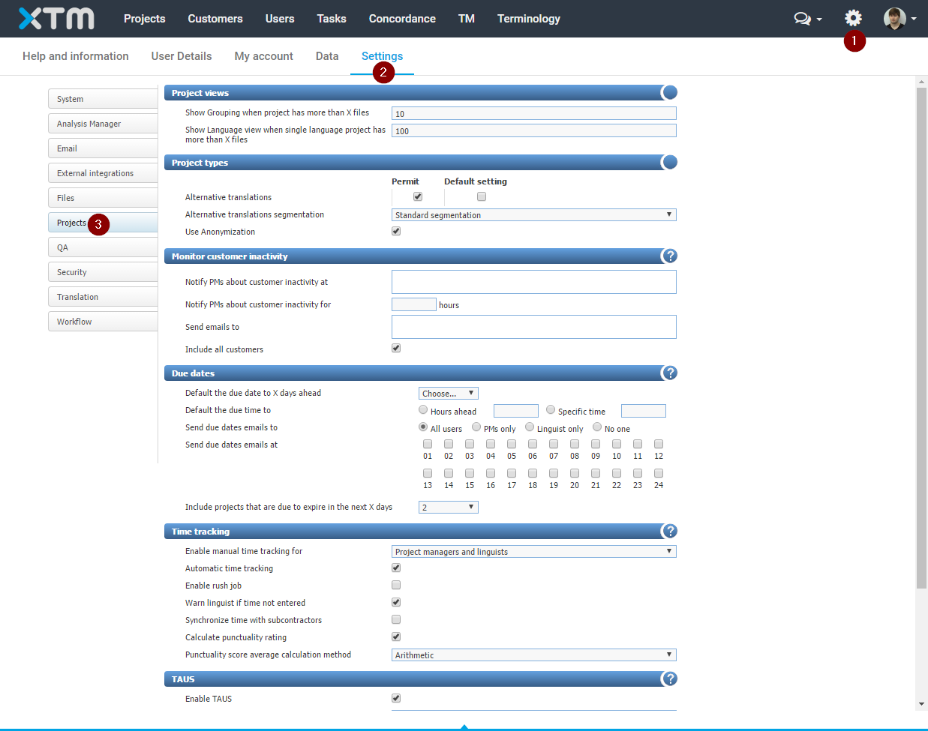

1. Select Enable TAUS, and provide the TAUS email address and password to use by default for customers and users who do not have their own TAUS account. Then click the Save button.

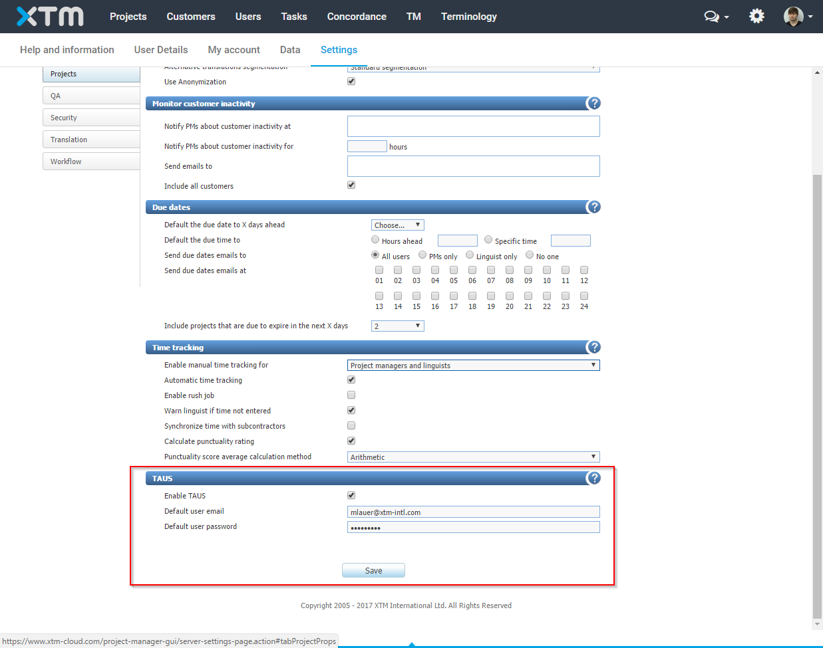

Customer configuration

1. Go to the Customers tab > Customer list and select a customer.

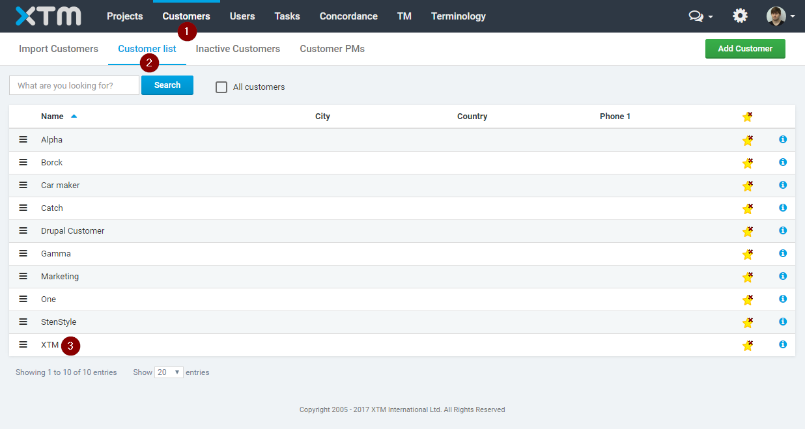

1. Click the Settings tab, and scroll down. Select Enable TAUS, and provide the TAUS email address and password to use by default for this customer and users who do not have their own TAUS account. Then click the Save button.

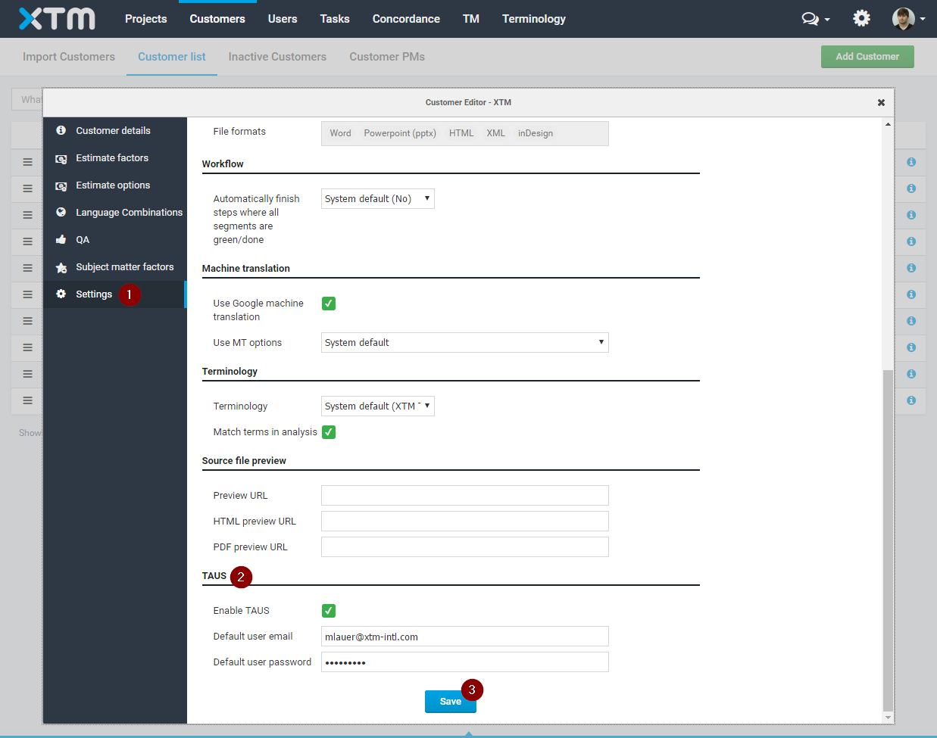

User configuration

Each user can configure their individual credentials for the connection with TAUS.

1. Go to the Configuration tab > User Details.

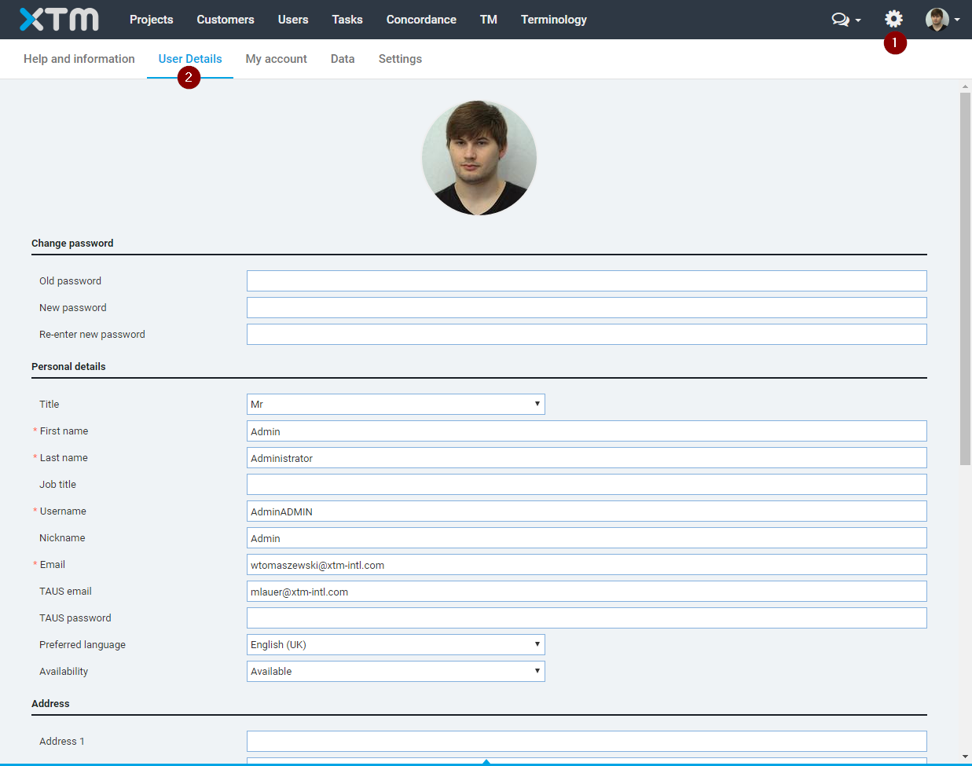

1. Provide the TAUS email address and password for this user. Then click the Save button.

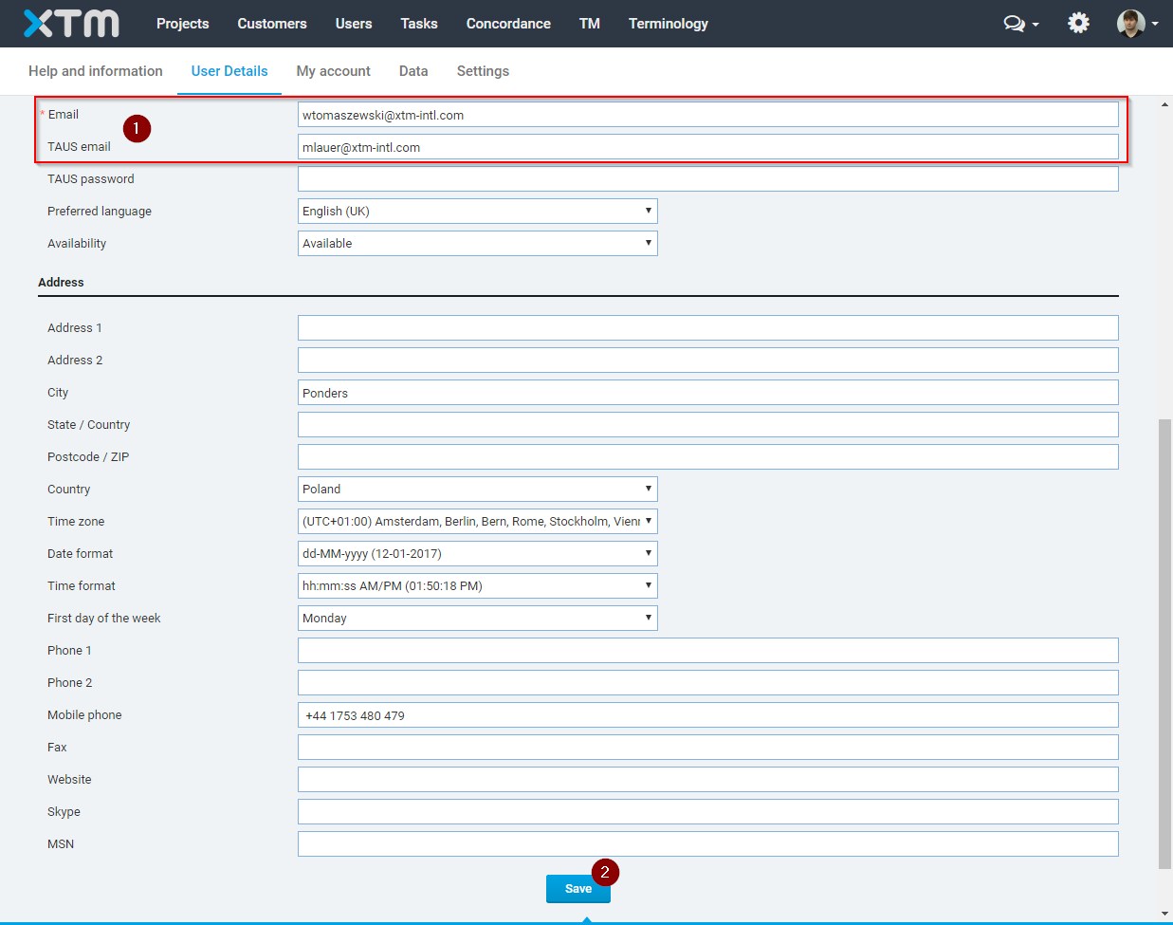

Project Managers and Administrators can also configure TAUS connection details for Users and LSPs on the General tab of Users or LSPs. The User and LSP editors are available on the Users tab > User list and Users tab > LSPs respectively.